Purchasing Executive – Next Generation Travel

NGT is the innovative parent company and driving force behind the UK’s fastest growing educational travel brands; offering unique, immersive tours to young people, from 10-21 years, designed to open minds and empower learning.

Our Vision - To be the trusted partner of choice for a broad range of high-quality educational tours and experiences.
Our Mission - To enhance educational outcomes for young people through inspiring, content-rich learning experiences, created by experts who care.

The role of Purchasing Executive for the NGT Group, will work across all trading brands including WST, Anglia Tours, FHT, Sports & Study Experiences, for all aspects of the product supply, with responsibility for supplier negotiations, contracting and stock management

What will you do in the role?

Negotiate competitive rates, stock levels and contract terms with suppliers in line with the purchasing strategy, bed briefs and budgeted rates, as provided by the NGT Head of Product & Purchasing.

Take a proactive approach to finding new sources of accommodation and tour services to meet demand.

Ensure all suppliers have robust Health & Safety processes, insurances and a service level agreement in place. Support the Group Supplier Relationships Manger with STF audits.

Renegotiation of contracts in line with budgeted annual inflation and average rate targets, identifying and negotiate offers, overrides, and marketing contributions from key suppliers, to give competitive advantage in the sector.

Ensure all suppliers contract renewals are signed within set deadlines, to ensure a continuity of and timely supply of services into the business, to minimise the need to cost on estimated rates.

Review of CDQ’s, post trip feedback, supporting the investigation & resolution of complaints, and adherence to contract terms.

Build and maintain strong relationships with existing and new suppliers to maximise all commercial opportunities, with regular business travel, attendance of FAM trips, industry events, and networking events to maximise the opportunity for face to face meetings.

Support the finance, sales and operations teams with product updates, training and respond to any day to day queries in a timely manner.

Ensuring all contracts are completed accurately and in full with all information required from a legal, financial and operational perspective by the wider business, with details recorded in the appropriate system or process.

This role is for you if:

- Have strong commercial acumen with prior experience in contracting, negotiating and strong relationship management skills.
- Are used to working in a fast paced environment and thrive on delivering market leading competitive services and products into the business.
- You are a highly organised, adaptable, conscientious, a proactive problem solver who enjoys looking for ways to improve the efficiency and effectiveness of the approach to purchasing.
- A knowledge of Microsoft tools with the ability to effectively use IT systems and are proficient at utilising commercial MI reports to proactively identify where supply is short or cost of sale needs negotiating to improve sales conversion.
- Are passionate about customer satisfaction and driven to create successful long term commercial supplier relationships by travelling to key destinations to build personal relationships with key suppliers.
- You are self-motivated, positive, resourceful with excellent organisational and planning skills and can work under pressure to meet deadlines, have an eye for detail and are able to work, successfully, with a high degree of autonomy.
- The ability to handle multiple and competing priorities whilst maintaining meticulous attention to detail and a proactive approach to communication.
- Have written and spoken French, Spanish or German fluency (other language skills would be desirable).

About Next Generation Values and Behaviours
The successful candidate will be expected to behave in a manner equal to the position.

This role requires flexibility of hours, passion for service delivery, energy application and vision as required by the business. This role will also require the post holder to travel overseas and in the UK.

NGT’s Behaviours are that we will :

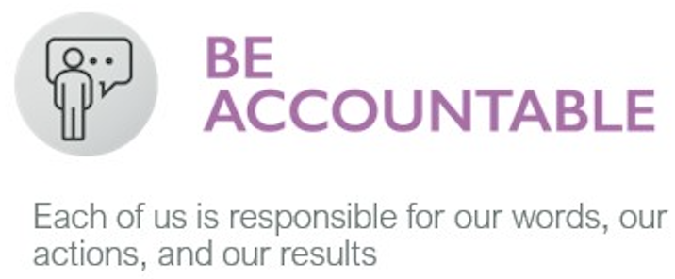
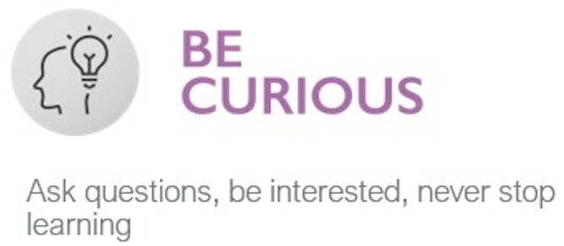
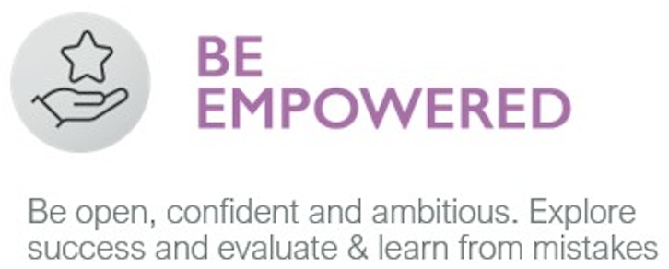
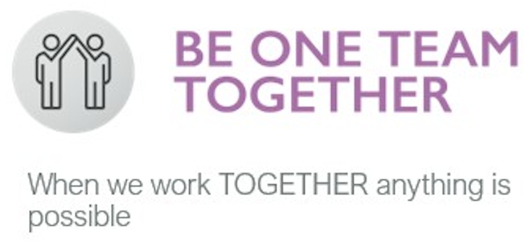
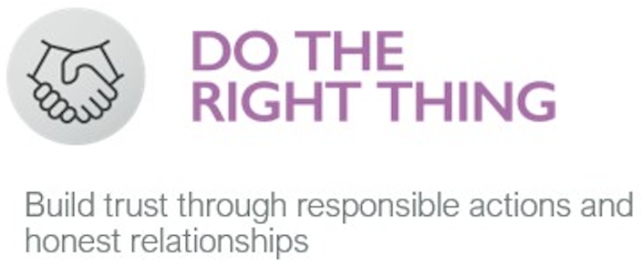

All of the above behaviours will be supported by our experienced senior management team and continual learning practices.

Being part of NGT’s team means that you will benefit from an annually reviewed salary, regular training & development opportunities and working within an exciting, energetic and innovative culture where reward and recognition are aligned with our success from working together.

