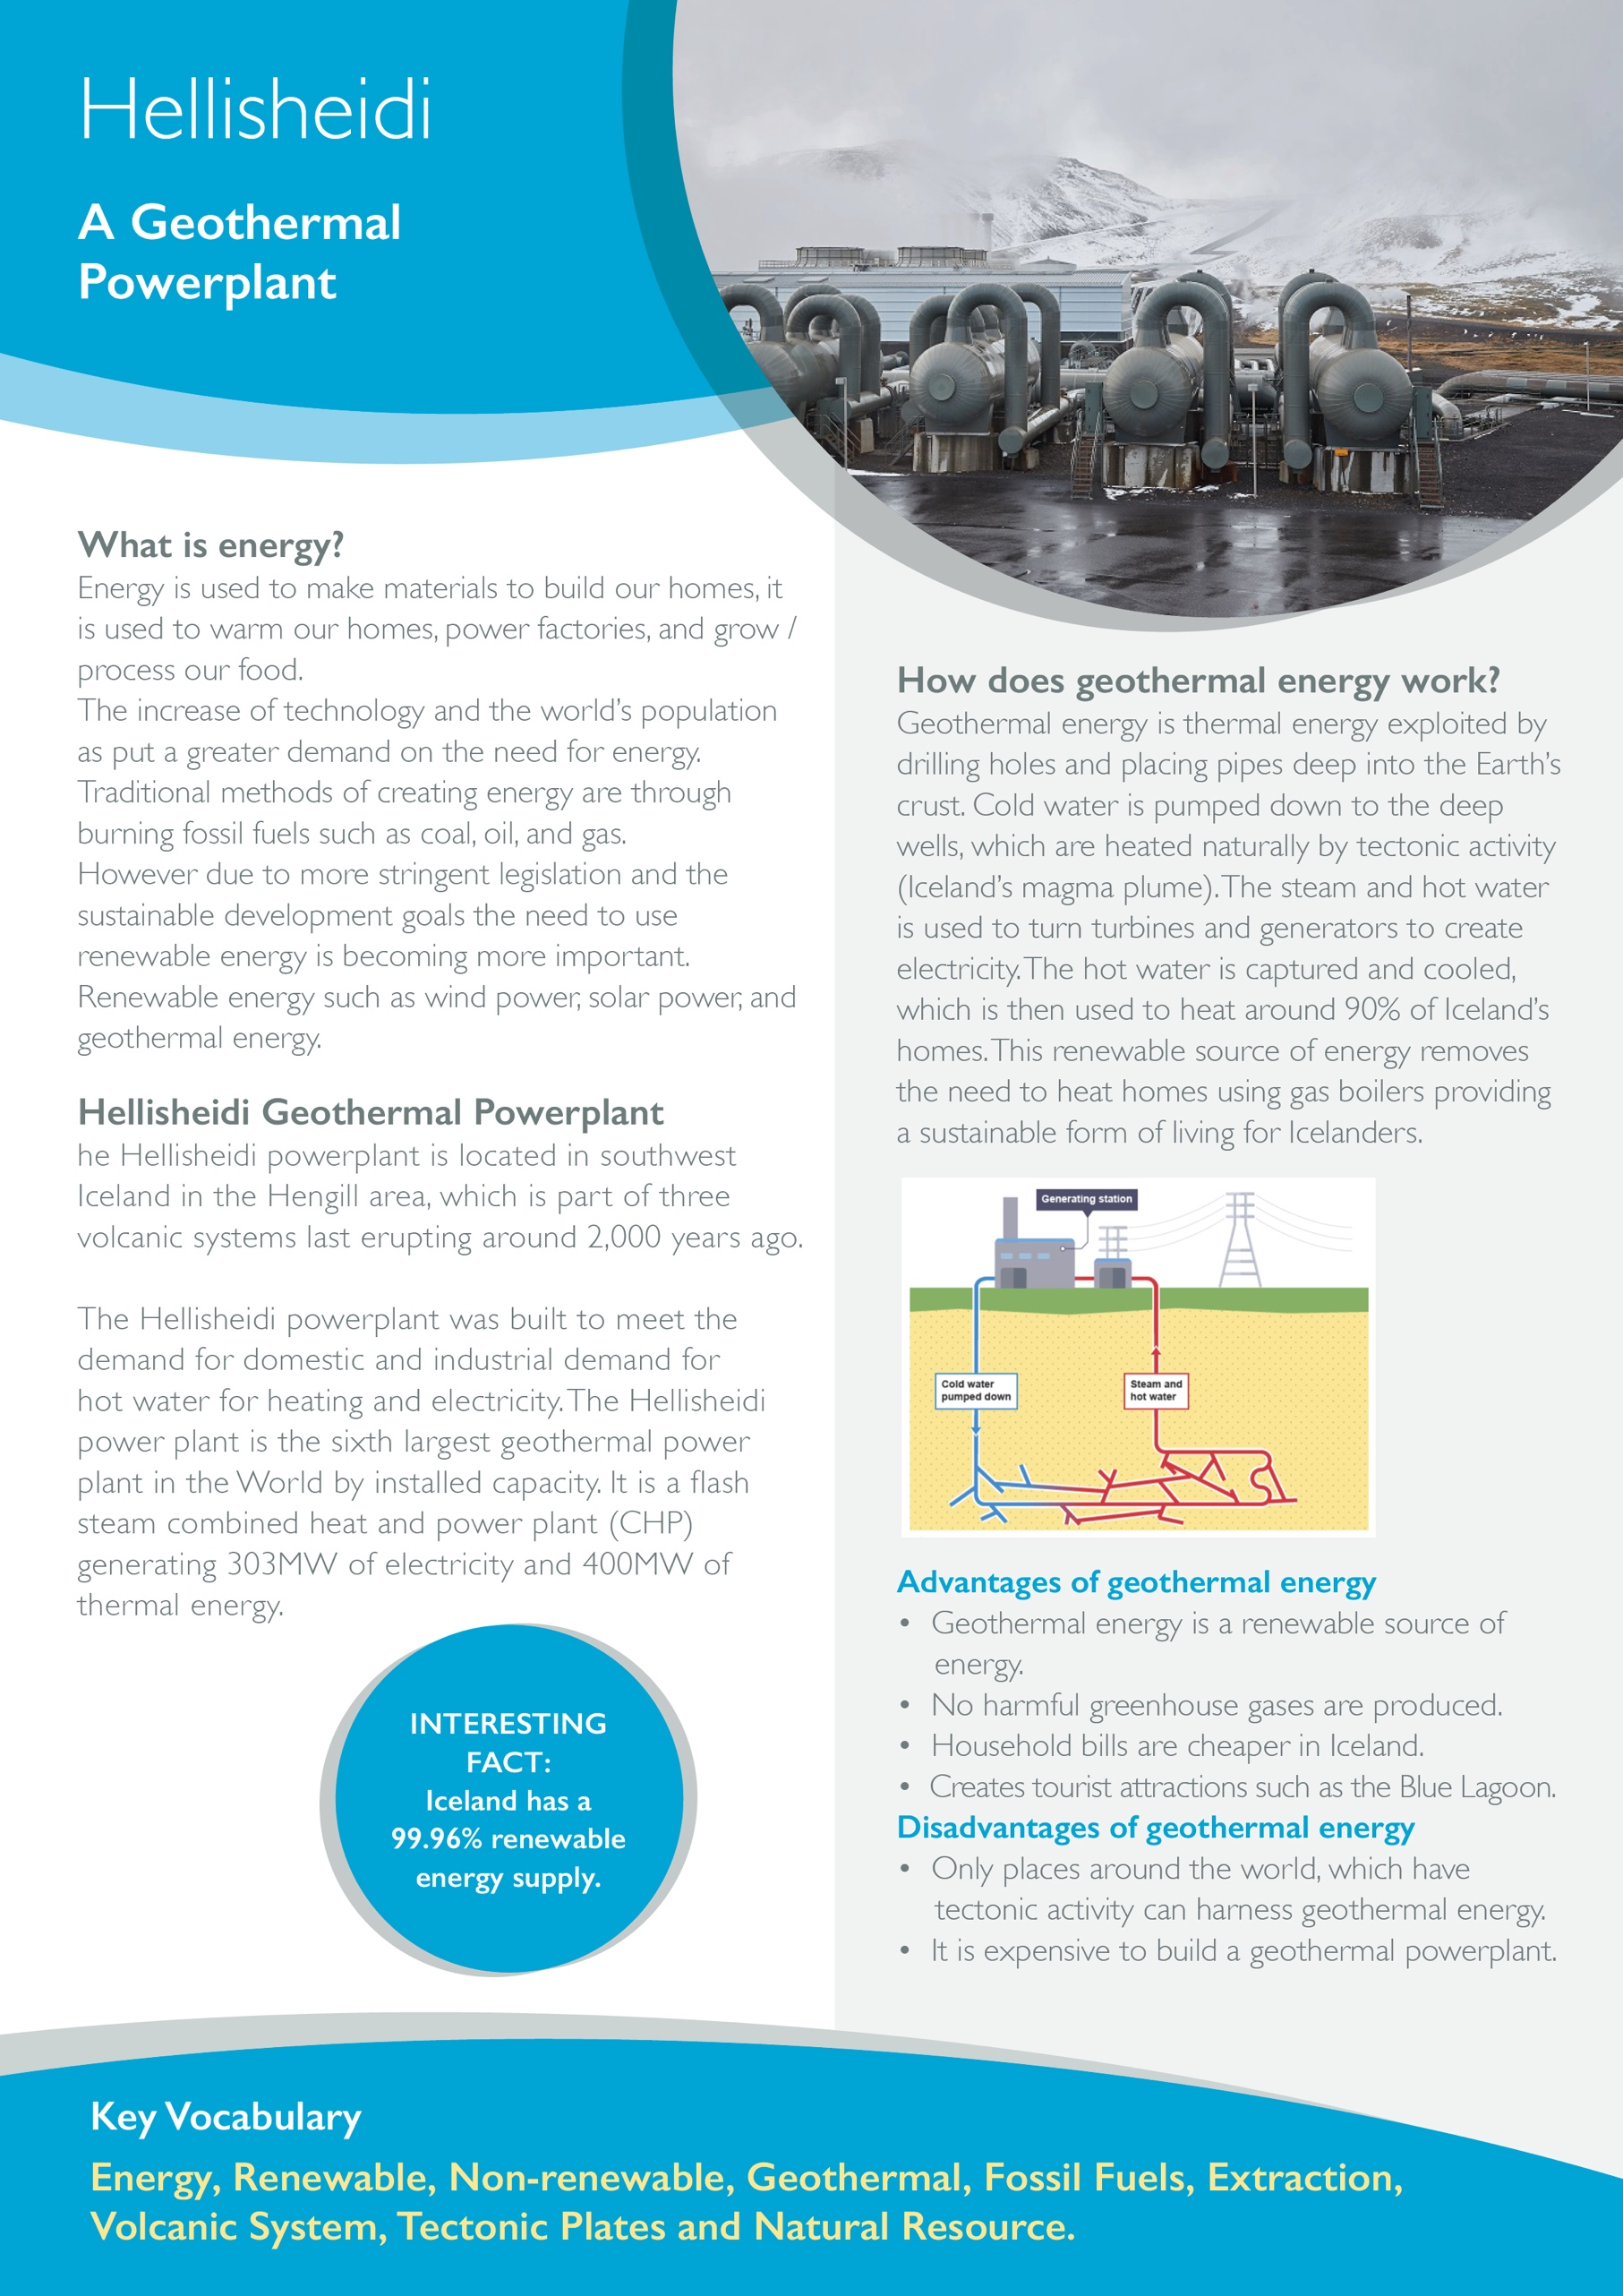



**Crossword Puzzle**

Across:

1. A source of energy, which doesn’t run out when used and is finite. E.g. wind and solar.

3. The Earth’s crust is broken into many pieces, which float above the mantle. E.g. Eurasian plate.

4. A greenhouse gas released when fossil fuels are burnt.

Down:

2. A type of energy, which harnesses the heat from hot rocks and creates electricity and hot water.

5. The blue lagoon in Iceland is created by geothermal energy and forms part of which industry in Iceland?

**Fill in the Gaps**

Geothermal e_________ is exploited by drilling deep down into the earth’s c____________. Cold water is   
p­­____________ down into deep wells. The cold water is then h__________ by h_____ r________ and turns the cold water into s___________. The s__________ is used to turn generators and t____________ to create e_______________. A by product of this process is hot water which is used to h__________ homes in I______________.

**Geothermal energy is a sustainable way of creating energy and only has positive impacts. ‘To what extent do you agree?’**

________________________________________________________________________________________________________________________________________________________________________________________________________________________________________________________________________________________________________________________________________________________________________________________________________________________________________________________________________________________________________________________________________________________________________________________________________________________________________________________________

