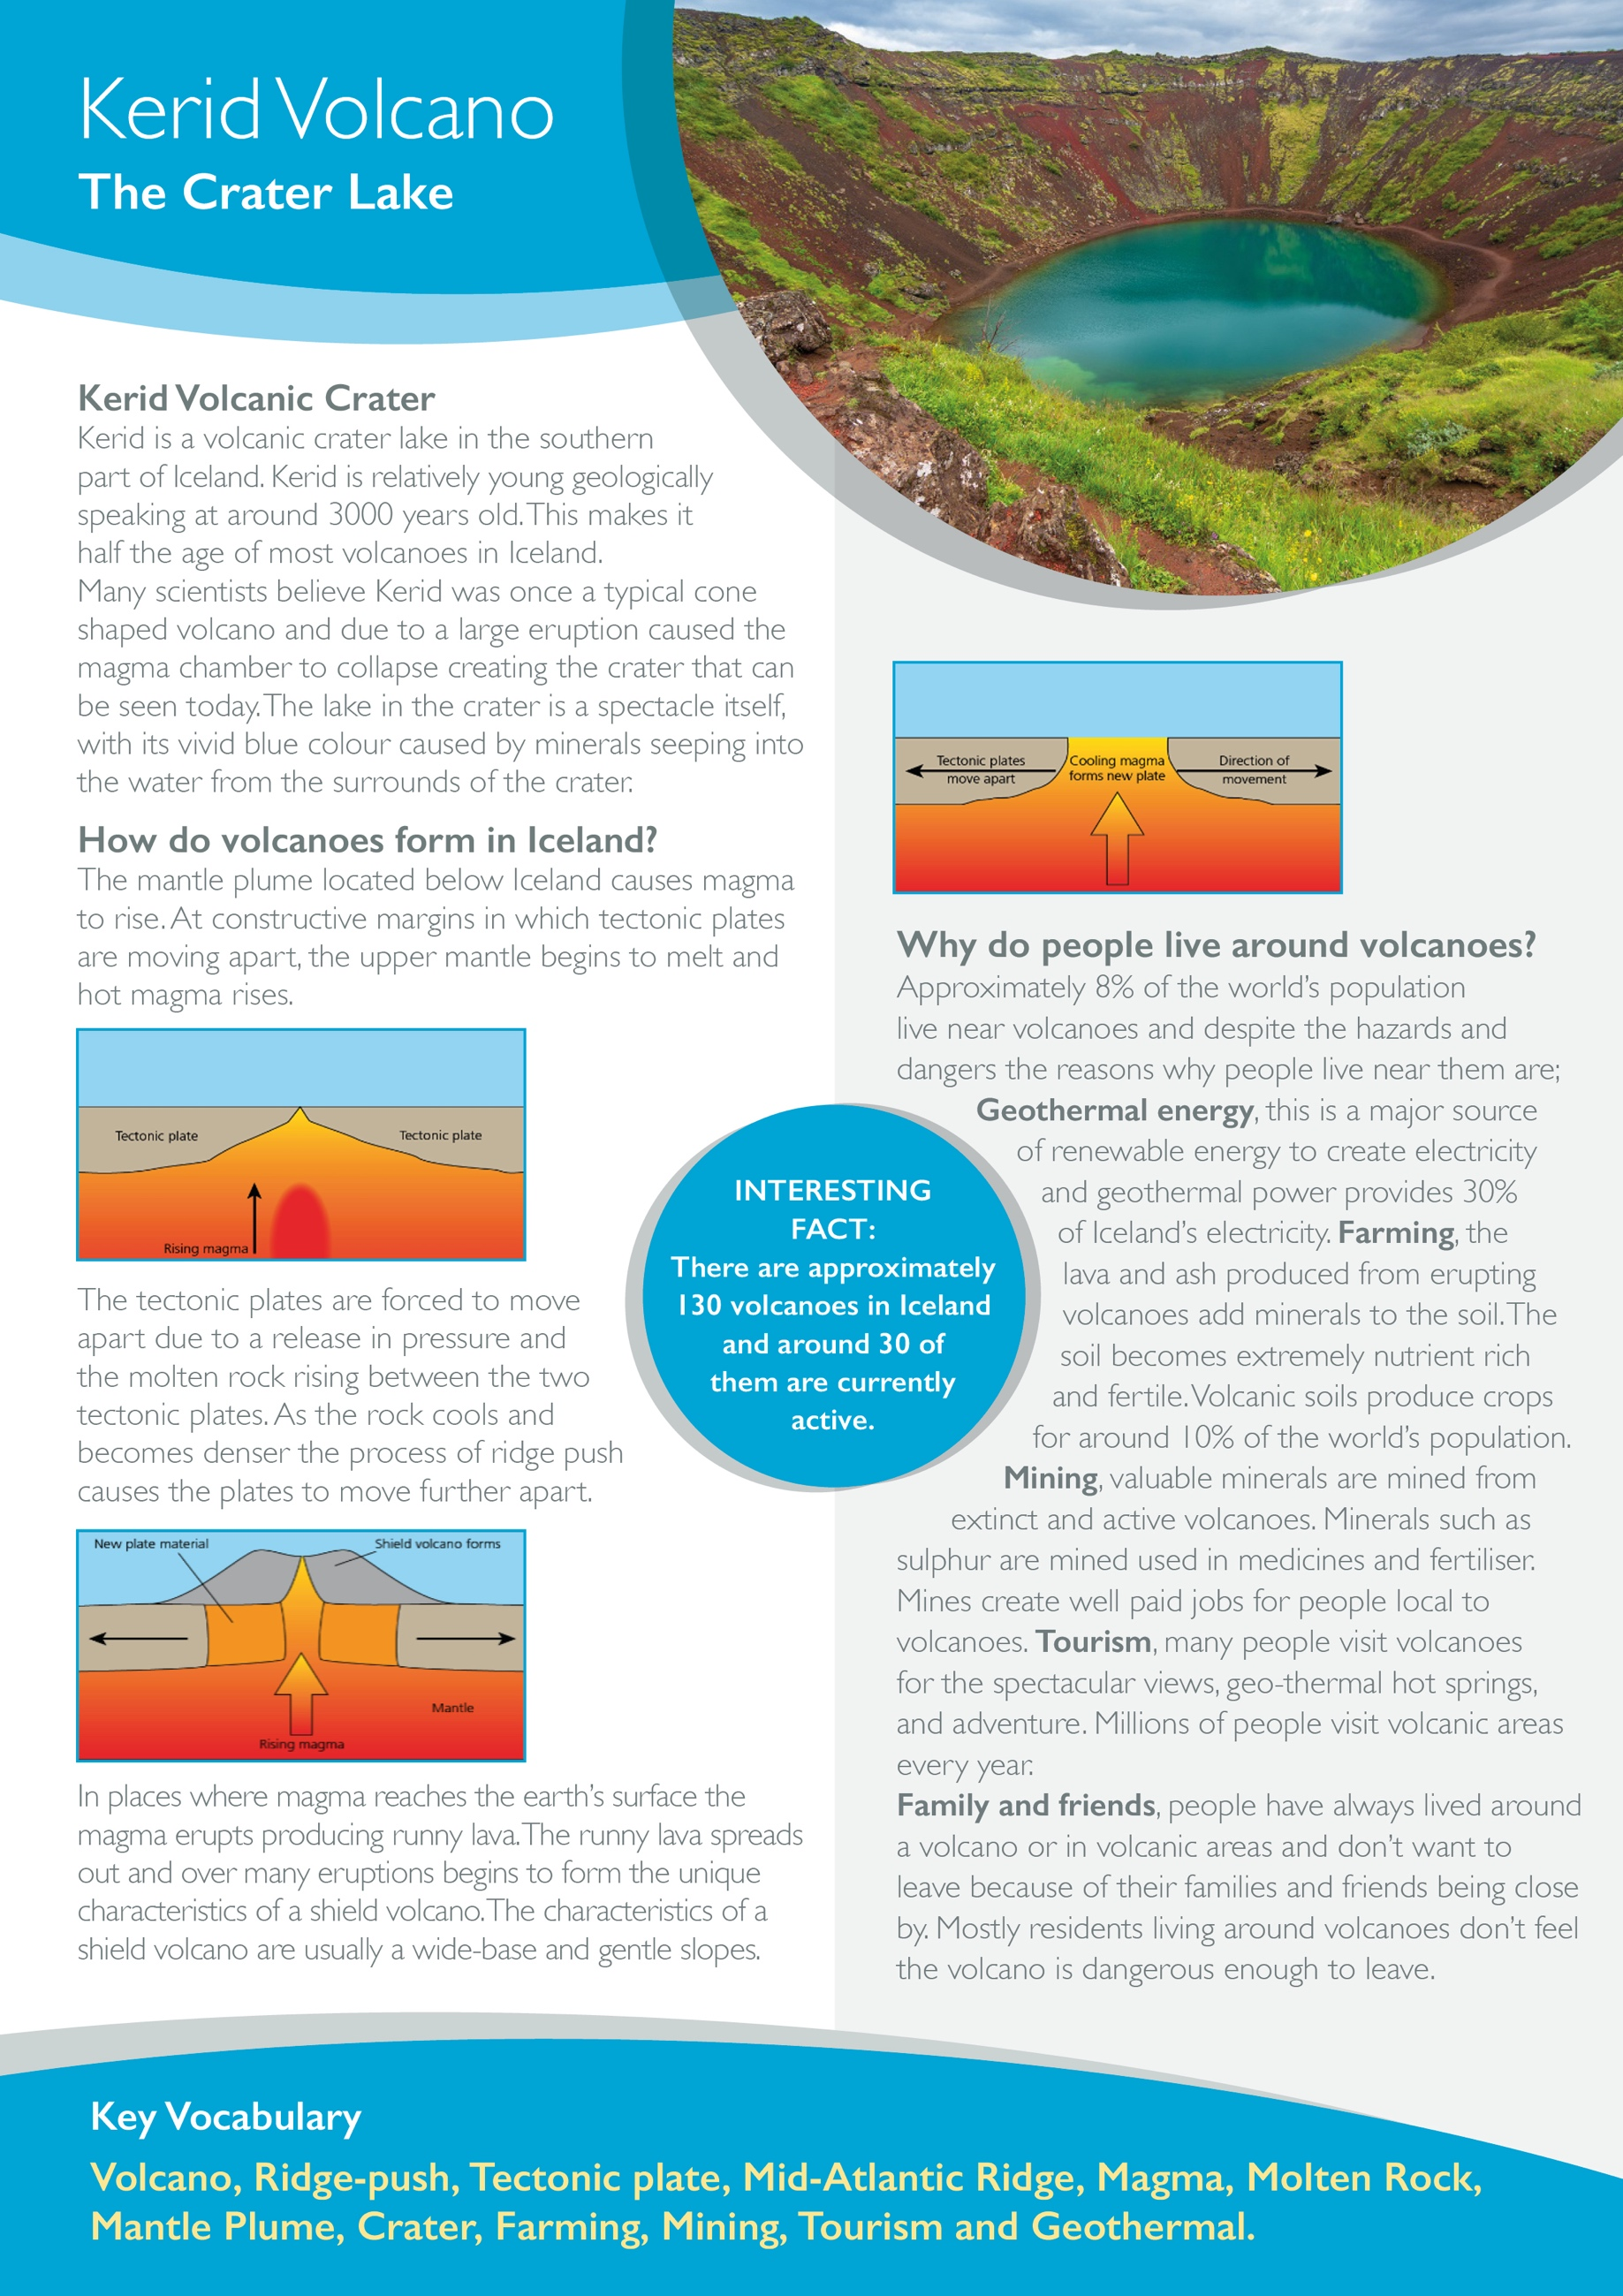

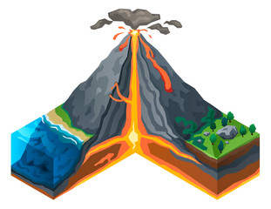**Label the diagram of the volcano.**

**Magma Chamber**

**Vent**

**Layers of Ash**

**Layers of Lava**

**Crater**

**Define it. (Write a definition for the following key terms)**

Volcano – Ridge push -

Tectonic Plate – Mantle plume -

Magma - Shield volcano -

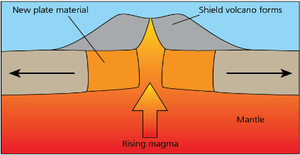

Using the diagrams above explain how volcanoes form in Iceland.

_______________________________________________________________________________________________________________________________________________________________________________________________________________________________________________________________________________________________________________________________________________________________________________________________________________________________________________________________________________________________________________________________________________________________________________________________________________________________________________________________________________________________________

