Information Sharing Agreement – Customer

TOUR CODE:

This Information Sharing Agreement (ISA) defines the arrangements for processing data between the Customer and the Company named below.

Parties to the agreement:

The Company | The Customer
Anglia Tours Limited
First Floor
Charles House
Kelvedon Road
Inworth
Essex
CO5 9SH

The following information about students and staff:

- Full name
- Date of Birth
- Place of Birth
- Nationality
- Passport number, date of issue and expiry
- Medical and/or dietary conditions
- Gender

is being shared by the Customer to enable the company named above to organise a school trip for our students and staff for trips travelling between [DATES].

The Customer has gained consent from the Parents/Guardians or Carers of the students to share this information with the Company and their representatives, who commit to the following conditions being fulfilled:

- The information will be stored and shared securely by the travel company.
- The Company will not pass these details on to any other organisation, unless agreement has been obtained from the Customer and providing the sharing is to help make the trip possible.
- The Company agrees to notify the Customer of any personal data breaches and to help the Customer meet their GDPR obligations, including providing support for audits where necessary, where these relate to data shared with the Company
- The Company will process personal data in accordance with its privacy policy (see link below) and on the website
- The information will be shared securely and records kept of any other organisation or individual with whom it has been shared
- The Company agrees to destroy the data once the trip and all related matters have been concluded
- Staff have been fully trained in GDPR and subject to a duty of confidence

PRIVACY POLICY: Here is a link to our current privacy policy. As this informs you on how we handle your personal data, we request that you please read this carefully.

This agreement must be formally approved and signed by both parties before any information sharing takes place. Both parties will ensure that the ISA and any associated documents are known and understood by all staff involved in the process.
Alison Biegel  Head of Anglia  Anglia Tours Limited  Signature  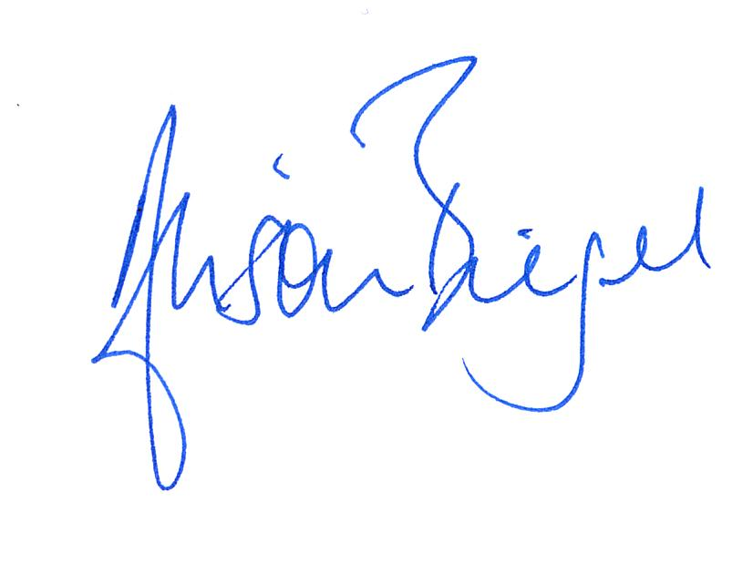  Date 01/01/2022 | Name:  Post held:  Organisation  Signature  Date

