Information Sharing Agreement – Customer

This Information Sharing Agreement (ISA) defines the arrangements for processing data between Anglia Tours Limited and the individual named in the right-hand box below.

Parties to the agreement:

The Company | The Customer
Anglia Tours Limited
First Floor
Charles House
Kelvedon Road
Inworth
Essex
CO5 9SH

Anglia Tours Limited is a UK based Tour Operator specialising in Group Travel, registered with the ICO. The Company’s Privacy Policy is available to view at: http://angliatours.co.uk/privacy-policy/.
In order to deliver contracted services to its customers Anglia Tours Limited is required to collect, retain and share various items of personal data or personal sensitive information which has been provided to it by its customers.

The following information is being shared by the Customer to enable Anglia Tours Limited to organise a ⃰ Tour / Battlefield Study for its ⃰ colleagues / members / personnel.

- Full name
- Date of Birth
- Place of Birth
- Nationality
- Passport number, date of issue and expiry
- Medical and/or dietary conditions
- Gender

The Customer confirms it has gained consent from all ⃰ colleagues / members / personnel to share personal data or personal sensitive information with Anglia Tours Limited but only if the following conditions are fulfilled:

⃰ Delete as appropriate

- The information will be stored securely by Anglia Tours Limited
- Anglia Tours Limited will not share these details with any other organisation or individual, unless agreement has been obtained from the Customer and providing the sharing is to help make the trip possible.
- The information will be shared securely and records kept of any other organisation or individual with whom it has been shared
- Anglia Tours Limited agrees to destroy the data once the trip and all related matters have been concluded
- Anglia Tours Limited agrees to help the Customer to meet their GDPR obligations, where these relate to data shared with the Company, and to notify the Customer of any personal data breaches

This agreement must be formally approved and signed by both parties before any information sharing takes place. Both parties will ensure that the ISA and any associated documents are known and understood by all staff involved in the process.

Alison Biegel  Head of Anglia  Anglia Tours Limited  Signature  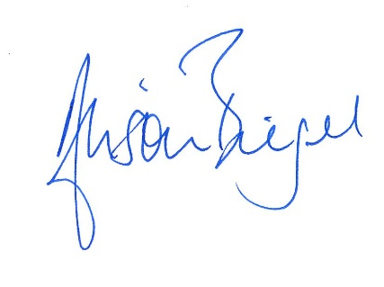  Date | Name:  Post held:  Organisation  Signature  Date

