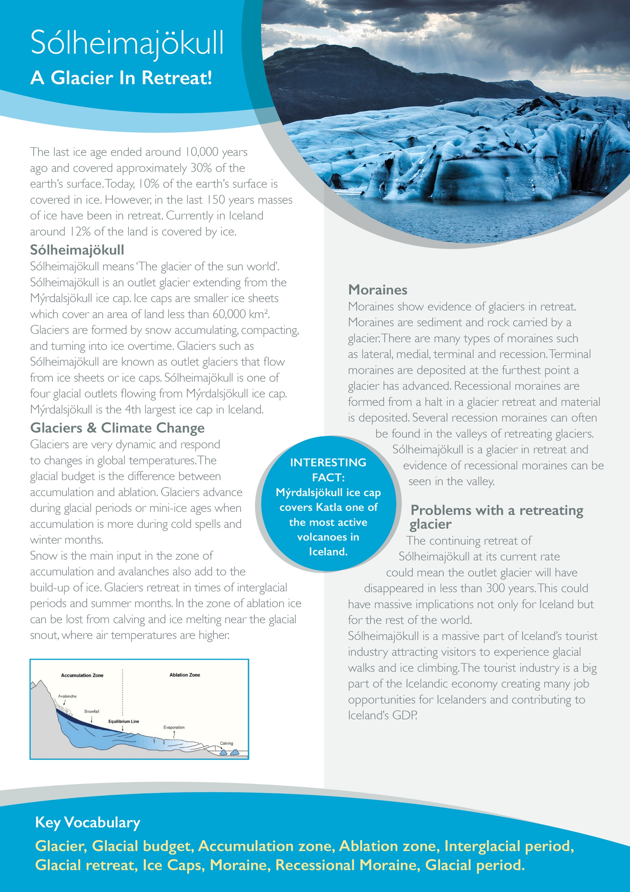

**Match up the keywords**

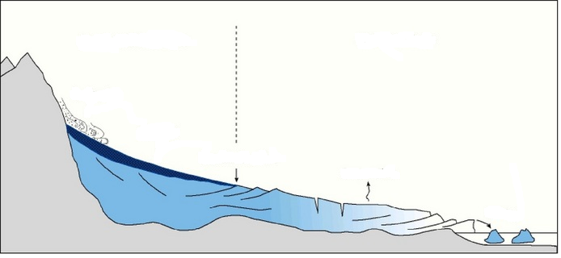

**Complete the diagram of the glacial budget.**

|  |  |  |
| --- | --- | --- |
| Glacier |  | Moraine ridges formed by a glacier halting and in retreat. |
| Glacial budget | Area of a glacier where ice is lost through melting or calving. |
| Accumulation zone | A moraine ridge that marks the furthest point a glacier as advanced. |
| Ablation zone | A warmer period of time between ice ages in which glaciers retreat. |
| Terminal Moraine | A moving mass of ice in a valley. |
| Recessional Moraine | A measurement of the inputs of a glacier considering accumulation and ablation. |
| Interglacial Period | An area of land covered in ice, normally found in polar regions. |
| Ice Cap | Area of a glacier where more snow and mass are gained and not lost. |

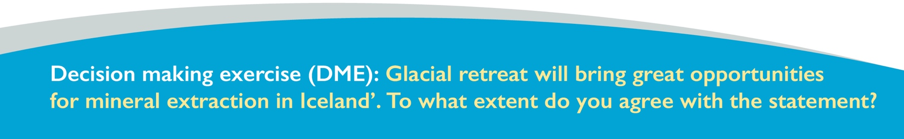

**Using an annotated diagram, explain how terminal and recessional moraines form.**

**Explain the two factors controlling the glacial budget.**

____________________________________________________________________________________________________________________________________________________________________________________________________________________________________________________________