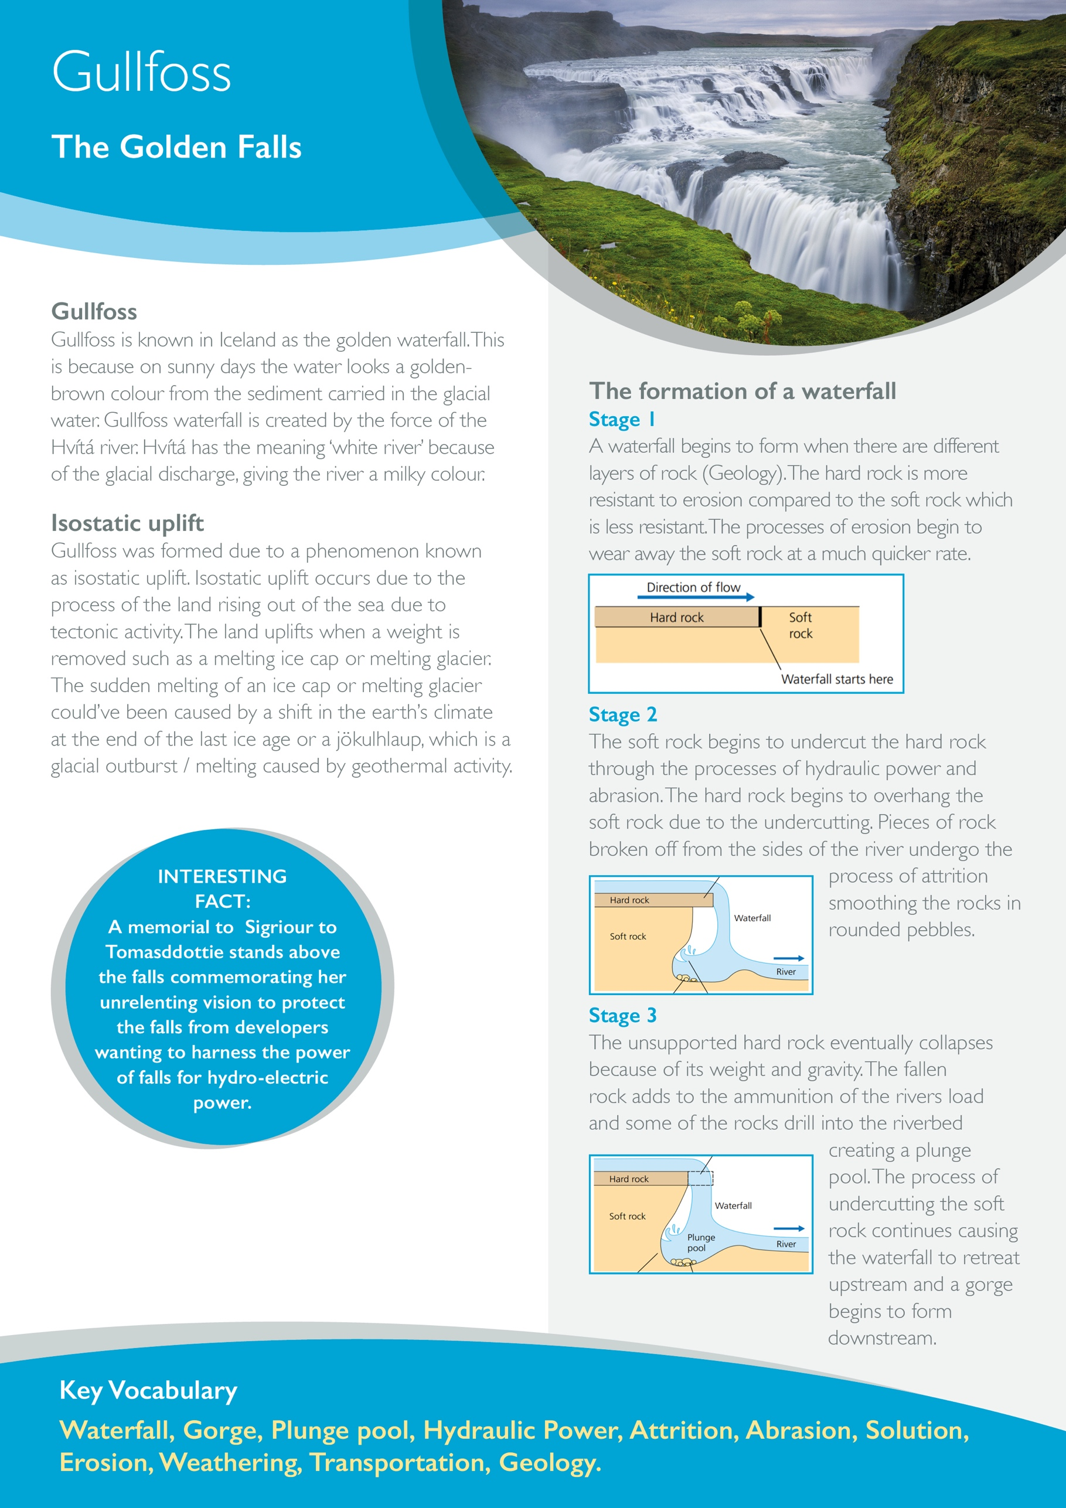

**True or False**

|  |  |
| --- | --- |
| Erosion is the breaking down of rocks, through freeze-thaw weathering. |  |
| Abrasion is the wearing away of the riverbed and riverbank by rocks and boulders (sandpaper effect). |  |
| Attrition is when rocks are carried by the river hit and smash against each other causing the rocks to break and become rounder, smaller and smoother. |  |
| Hydraulic Power is the process of which water falls into cracks on the riverbank and freezes. The frozen water (ice) expands by 9% breaking the rock slightly widening the crack. Overtime and a repeat of this process will eventually break the rock apart. |  |
| A gorge is a narrow steep sided valley formed by a retreating waterfall. |  |
| Gullfoss is known as the golden waterfall because the water looks a golden-brown colour on sunny days. |  |
| A memorial of Sigriour is located above Gullfoss because she was the first woman to successfully kayak down the falls. |  |

**Re-write the sentences above that are false so they make sense and become true.**

_______________________________________________________________________________________________________________________________________________________________________________________________________________________________________________________________________________________

|  |  |  |
| --- | --- | --- |
| **Create a cartoon strip to explain the formation of a waterfall. (Use annotations)** | | |
|  |  |  |
|  | Erosion causes the soft rock to undercut leaving an overhang. |  |
|  |  |  |
|  |  | Downstream of the waterfall a gorge is formed. |

