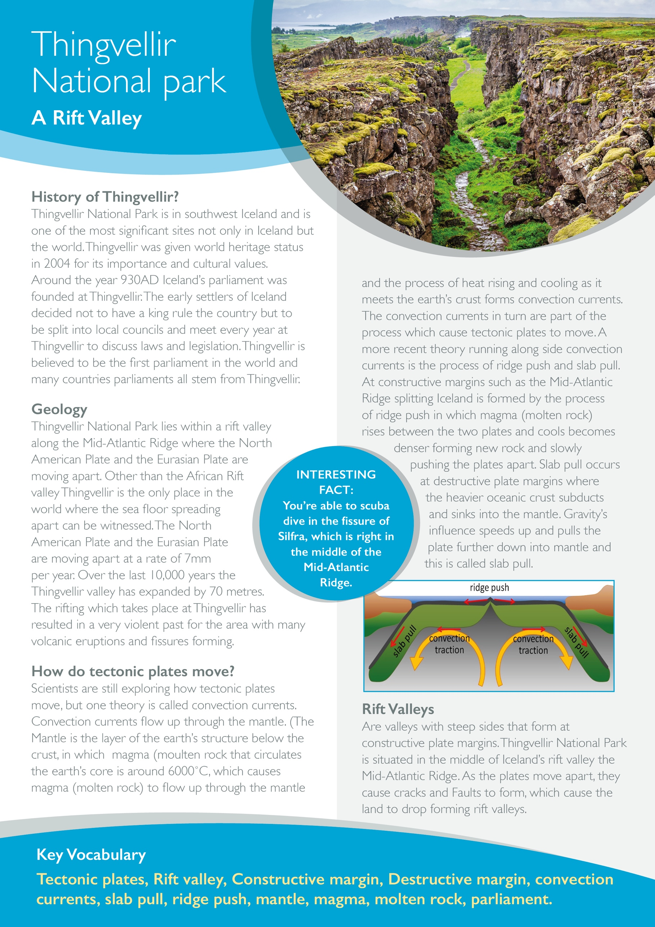

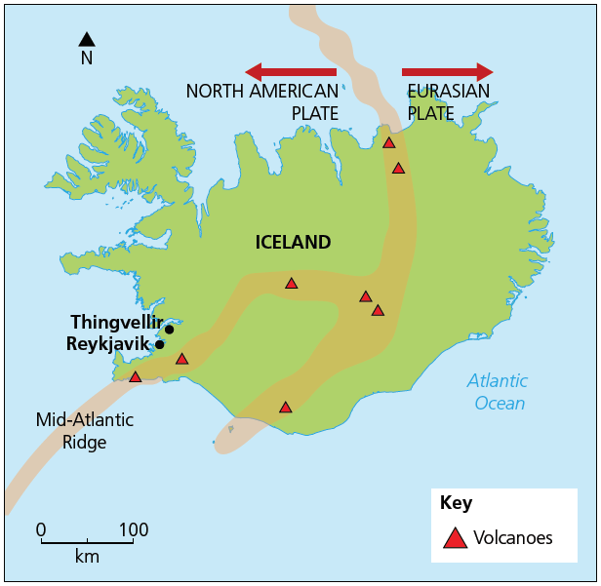

Using an annotated diagram, explain why the tectonic plates are moving apart forming the Mid-Atlantic Ridge.

**Match up the keywords**

|  |  |  |
| --- | --- | --- |
| Rift Valley |  | When molten rock becomes dense causing it to push on tectonic plates and move them apart. |
| Convection Currents | A split in the earth’s crust where two tectonic plates are moving apart. E.g. Mid-Atlantic Ridge. |
| Ridge Push | A steep sided valley caused by two tectonic plates moving apart on land. |
| Slab Pull | The circular movement of magma (molten rock) in the mantle. |
| Constructive Margin | When the weight of gravity pulls on a subducting tectonic plate. |

**Explain why Thingvellir National Park is a famous rift valley.**

__________________________________________________________________________________________________________________________________________________________________________________________________________________________________________________________________________________________________________________________________________________________________________________________________________________________________________________________________________________________________________________

