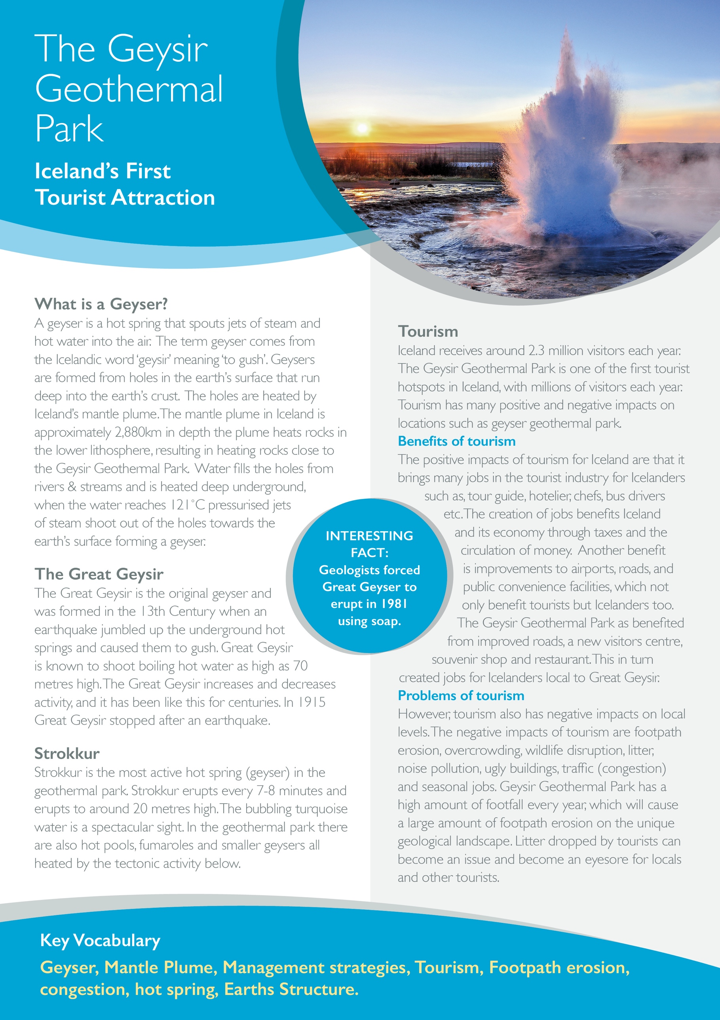



Label the diagrams with the correct number from the statements below – The formation of a Geyser

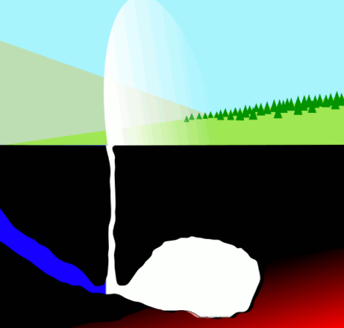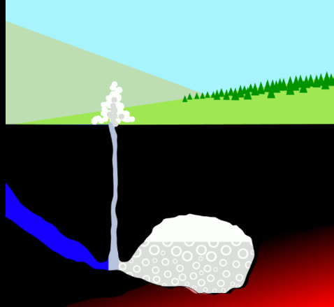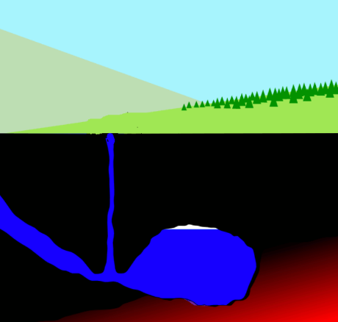

**Impacts of Tourism**

Sort the impacts of tourism into benefits and problems.

1. Footpath erosion

2. Money

3. Overcrowding

4. Jobs

5. Seasonal jobs

6. Traffic Congestions

7. Improvements

8. Attractions

9. Wildlife disruption

10. Litter

11. Noise pollution

12. Ugly Buildings

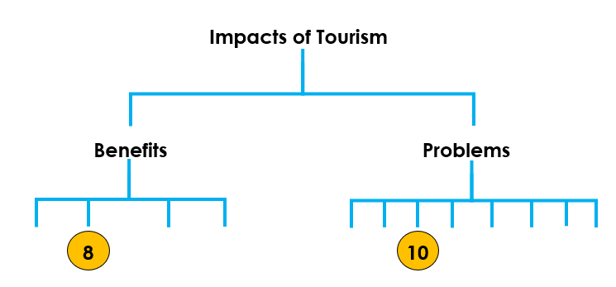

|  |  |
| --- | --- |
| Deep holes in the Earth’s crust fills with cold water from a stream or river. | **1** |
| The water deep underground is heated by the hot rocks and begins to boil. The hot rocks are heated by the mantle plumb underneath Iceland. | **2** |
| The water temperature reaches 121˚C causing pressurised jets to shoot out of the holes towards the Earth surface to form a geyser. | **3** |

|  |  |
| --- | --- |
| Explain four impacts of tourism on Iceland. (Benefits or Problems) | |
| **Money** |  |
|  |  |
|  |  |
|  |  |

